**DAILY ONLINE ACTIVITIES SUMMARY**

|  |  |  |  |  |  |  |  |  |
| --- | --- | --- | --- | --- | --- | --- | --- | --- |
| Date: | 23/05/2000 | | | | | Name: | Jyothi B R | |
| Sem & Sec | IV-A | | | | | USN: | 4AL18CS030 | |
| Online Test Summary | | | | | | | | |
| Subject | | Data Communication | | | | | | |
| Max. Marks | | 30 | | Score | | | 28 | |
| Certification Course Summary | | | | | | | | |
| Course | Programming Essentials in Python | | | | | | | |
| Certificate Provider | | | Cisco Virtual Academy | | Duration | | | 2hrs |
| Coding Challenges | | | | | | | | |
| Problem Statement: Find the triangular series using c program. | | | | | | | | |
| Status:Completed | | | | | | | | |
| Uploaded the report in Github | | | | | Yes | | | |
| If yes Repository name | | | | | https://github.com/JyothiShetty/lockdown-coding | | | |
| Uploaded the report in slack | | | | | Yes | | | |

Online Test Details: (Attach the snapshot and briefly write the report for the same)

Certification Course Details: (Attach the snapshot and briefly write the report for the same)

Coding Challenges Details: (Attach the snapshot and briefly write the report for the same)

ONLINE TEST DETAILS:

The online test was from module 1 and module 2. There were 30 questions which contains 30 mcq questions and the duration were 40 minutes. The questions were optimal and easy. The score that I received was 28/30.

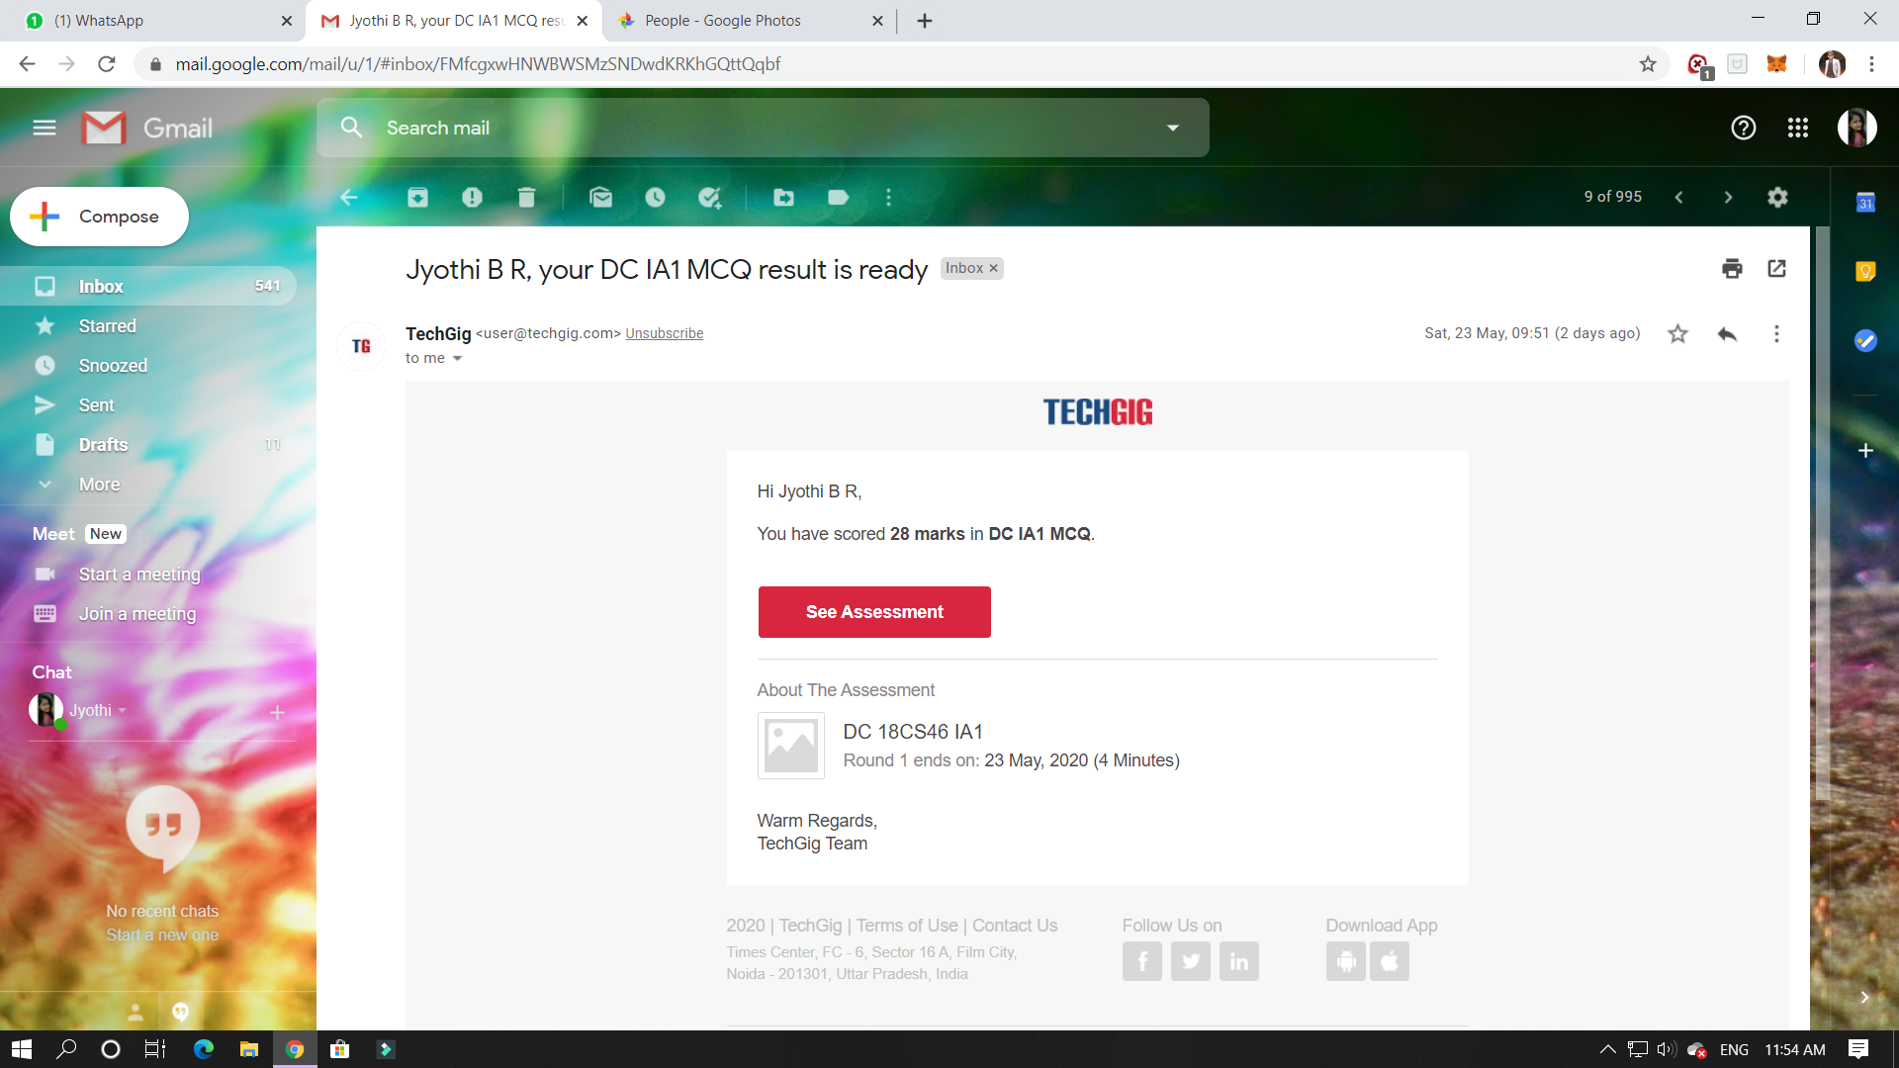

CERTIFICATION COURSE DETAILS:

Programming Essentials in Python :

In the program:

* creates a one-element list named list1;
* assigns it to a new list named list2;
* changes the only element of list1;
* prints out list2.

The surprising part is the fact that the program will output: [2], not [1], which seems to be the obvious solution.

Lists (and many other complex Python entities) are stored in different ways than ordinary (scalar) variables.

You could say that:

* the name of an ordinary variable is the **name of its content**;
* the name of a list is the name of a **memory location where the list is stored**.

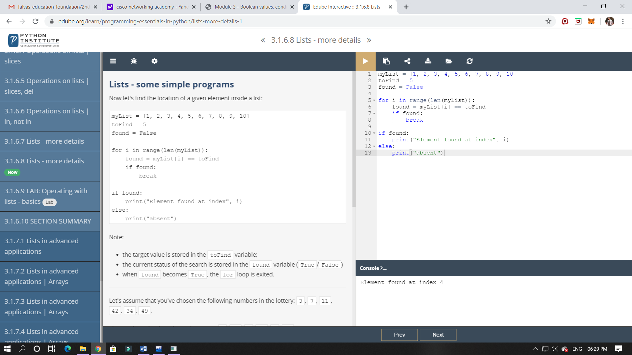

ONLINE CODING:

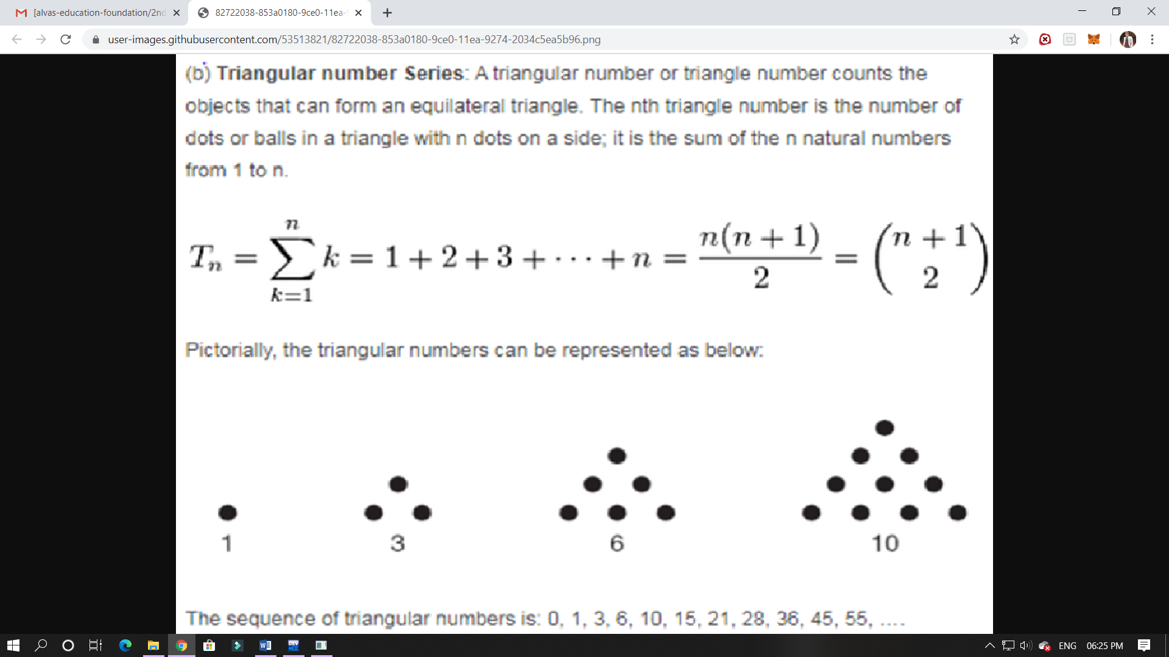

Solution:

